**OSI (Open Systems Interconnection)**

The OSI (Open Systems Interconnection) model is a conceptual framework used to understand network interactions in seven layers. Each layer serves a specific function and communicates with the layers directly above and below it. Here’s a simple breakdown and a diagrammatic representation of how data flows through these layers when two devices communicate over a network.

**OSI Model Layers:**

1. **Physical Layer (Layer 1):** Deals with the physical transmission of raw data bits over a communication channel. This includes the layout of pins, voltages, cable specifications, etc.
2. **Data Link Layer (Layer 2):** Manages the node-to-node data transfer, packaging raw bits into frames. This layer also handles error checking and flow control.
3. **Network Layer (Layer 3):** Responsible for data transfer between different networks. This involves routing of packets, including addressing and forwarding.
4. **Transport Layer (Layer 4):** Ensures complete data transfer. It provides services such as segmentation, acknowledgment, and traffic control.
5. **Session Layer (Layer 5):** Manages sessions between applications. This includes establishing, managing, and terminating connections between applications.
6. **Presentation Layer (Layer 6):** Translates data from a format used by the application layer into a common format at the sending station, then back into a format understandable by the application layer at the receiving station.
7. **Application Layer (Layer 7):** Closest to the user. It provides network services directly to applications. This layer includes things like HTTP for web browsing, SMTP for email, FTP for file transfers, etc.

**Data Flow in the OSI Model:**

Here's how data flows from the source to the destination:

**Sending Device**

* **Application Layer (7):** Data is generated (e.g., an email) and passed down with appropriate headers for each layer.
* **Presentation Layer (6):** Data is formatted or encrypted as necessary.
* **Session Layer (5):** Establishes and maintains a connection with the recipient for the duration needed to transfer data.
* **Transport Layer (4):** Segments the data and may add reliability and flow control information.
* **Network Layer (3):** Adds logical addressing and chooses the routing path.
* **Data Link Layer (2):** Frames the data, adding physical addressing and error detection.
* **Physical Layer (1):** Converts data into electrical, optical, or radio signals and transmits it.

**Transmission Medium**

* Data travels, in whatever form, over the medium (cables, wireless, etc.)

**Receiving Device**

* **Physical Layer (1):** Receives the physical signal and converts it back into digital data.
* **Data Link Layer (2):** Processes frame data, checks for errors, and strips headers.
* **Network Layer (3):** Examines the destination address and forwards the packet as necessary.
* **Transport Layer (4):** Reassembles segments into data and performs error correction.
* **Session Layer (5):** Manages the connection and informs the receiving application that data is ready.
* **Presentation Layer (6):** Converts the data format to one suitable for the application layer.
* **Application Layer (7):** Delivers the data (e.g., displays the email) to the end user.

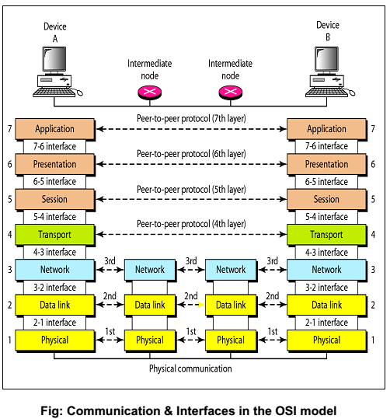

**TCP/IP**

The TCP/IP model, although it is based on the same principles as the OSI model, has fewer layers and is more widely used in real-world networking. The TCP/IP model consists of four layers, each corresponding roughly to a set of layers in the OSI model. Here’s a brief overview of each layer in the TCP/IP model and a description of how data flows through these layers.

**TCP/IP Model Layers:**

1. **Link Layer (Network Interface Layer):** Corresponds to the OSI's Physical and Data Link layers. It deals with the physical and hardware aspects of data transmission, such as the network interface card and the physical network structure.
2. **Internet Layer (Network Layer):** Corresponds to the OSI's Network Layer. This layer handles the logical transmission of data packets across the network, including the IP (Internet Protocol) addressing and routing.
3. **Transport Layer:** Corresponds to the OSI's Transport Layer. This layer is responsible for the reliable transmission of data segments between points on a network, including the control of data flow and error handling. TCP (Transmission Control Protocol) and UDP (User Datagram Protocol) operate at this layer.
4. **Application Layer:** Combines the OSI's Application, Presentation, and Session layers. It provides network services directly to the applications used by end-users. Protocols like HTTP, SMTP, FTP, and DNS operate at this layer.

**Data Flow in the TCP/IP Model:**

Here's how data flows from a source device to a destination through the TCP/IP model:

**Sending Device**

* **Application Layer:** An application generates data to send over the network, for example, an HTTP request or an email.
* **Transport Layer:** The data is broken into segments. TCP adds headers that include port numbers and sequence numbers. UDP, offering a connectionless service, includes fewer details.
* **Internet Layer:** Each segment is encapsulated into packets, IP headers are added including source and destination IP addresses.
* **Link Layer:** The packets are then framed, adding headers and footers for error checking, and the physical address. The data is converted into signals and transmitted over the physical medium.

**Transmission Medium**

* Data travels across various physical networks, which may include Ethernet, Wi-Fi, fiber optics, and other transmission mediums.

**Receiving Device**

* **Link Layer:** Receives the signals, converts them back to data, and processes the headers and footers for error checking.
* **Internet Layer:** Processes the packets, stripping headers and managing routing if necessary.
* **Transport Layer:** Reassembles segments into complete messages and performs error correction if necessary.
* **Application Layer:** Receives the complete data and makes it available to the application, such as a web browser or email client.

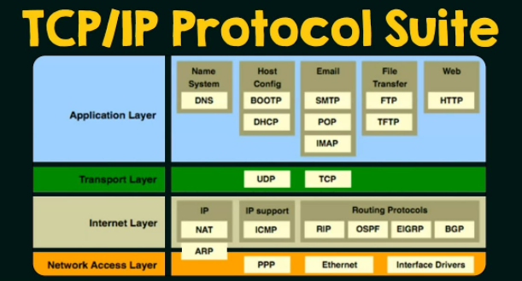

**User Datagram Protocol**

UDP, or User Datagram Protocol, is a communication protocol used across the Internet for time-sensitive transmissions such as video playback or DNS lookups, where losing some packets is preferable to waiting for delayed data. As a part of the Internet Protocol suite, UDP provides a simple service by exchanging messages, called datagrams, without establishing a connection between the communication partners.

**Key Characteristics of UDP:**

1. **Connectionless Protocol:**
   * UDP does not establish a connection before sending data. This means that datagrams (packets) can be sent immediately without waiting for an agreement with the recipient, leading to lower latency.
2. **No Error Recovery:**
   * UDP does not offer error recovery, so if a datagram is lost in transit, it will not be retransmitted. This is acceptable in many real-time applications where speed is more critical than precision, such as streaming audio or video.
3. **No Flow Control:**
   * With UDP, data packets can be sent in rapid succession without worrying about network congestion. This might lead to packet loss if the network becomes overloaded, but allows for very fast data transfer when the network is clear.
4. **Unreliable:**
   * Because it lacks error recovery capabilities, UDP is considered an unreliable protocol. Applications that use UDP must be prepared to handle errors and lost data.
5. **Low Overhead:**
   * UDP has a very small packet header—8 bytes—compared to TCP, which has a minimum header size of 20 bytes. This small header size reduces the data overhead for the packets transmitted across the network.

**How UDP Works:**

* **Sending Data:**
  + An application that uses UDP prepares data and sends it in blocks of bytes called datagrams. Each UDP datagram encapsulates the sender and receiver's port numbers, the datagram length, and a checksum. The datagram is then handed over to the IP layer, which delivers it to the receiver.
* **Receiving Data:**
  + At the receiver's end, the IP layer processes the incoming datagram, verifies the checksum, and if it matches, the datagram is passed to the UDP protocol. If there's an error in the checksum, UDP simply discards the packet; there is no notification of error sent back to the sender.

**Common Uses of UDP:**

* **DNS (Domain Name System):**
  + DNS queries are typically made using UDP because the data being transferred is small and a quick response is desirable without the overhead of establishing a connection.
* **Video and Audio Streaming:**
  + Services like streaming media often use UDP, as it allows for continuous streaming of data without interruption. Errors or losses manifest as minor glitches in audio or video, which are generally tolerable and often unnoticeable.
* **Online Games:**
  + Real-time multiplayer games use UDP because it reduces latency and lag, enhancing gameplay responsiveness. Players experience smoother gameplay even if some of the game state data is dropped.
* **Broadcast and Multicast Transmissions:**
  + UDP supports packet broadcasting to multiple hosts, making it suitable for tasks that involve sending messages to multiple devices simultaneously.

In conclusion, UDP is an essential protocol for situations where speed and efficiency are more critical than perfect accuracy. It plays a crucial role in modern Internet applications, particularly where timing and performance outweigh the need for precision and completeness of the transmitted data.